**UNIVERSITY OF DAR ES SALAAM**



**COLLEGE OF INFORMATION AND COMMUNICATION TECHNOLOGIES**

**DEPARTMENT OF COMPUTER SCIENCE AND ENGINEERING**

**IS 335: Final Year Project 2021/2022**

**PROJECT TITLE: AGRICULTURAL PRODUCTS MARKETING AND SHIPPING LOGISTICS SYSTEM (Mobile application module)**

|  |  |
| --- | --- |
| **Name of Candidate:** | **MHULI, STEPHEN ROBERT** |
| **Registration Number:** | **2019-04-07135** |
| **Name of supervisor:** | **DR. WILFRED SENYONI** |
| **Supervisor’s Signature:** | **…………………………** |
| **Submission Date** | **…………………………** |

# DECLARATION

I declare that this report and the work in it is my own work with contributions from others expressly acknowledged and/or cited.

I declare that the work in this report was carried out in accordance with the Regulations of the University of Dar es salaam and has not been presented to any other University for examination either in Tanzania or overseas. Any views expressed in the report are those of the author and in no way represent those of the University of Dar es salaam.

Signature: ..............................................

Date: ......................................................

This report may proceed for submission for assessment for the award of Bsc. in Computer Science at the University of Dar es salaam.

Supervisor’s Signature: ……………………………… Date: ……………………………

# 

# ACKNOWLEDGEMENT

First of all, I would like to thank the almighty God ,who has given me strength and ability to complete the project on time.

Next big thanks go to Dr. Wilfred Senyoni as my supervisor for this project and the opportunity given to me to do my final year project. I also would like to thank for his kind attention, great advice, brilliant ideas, and his guidance for helping me to complete this project from the beginning until the end of this project.

Also, I would like to pass my thanks to my fellow Final Year Project partner Mafie,Glory E who was participating well in making sure we perform and accomplish the tasks given, my friends and all others for their support.

Thirdly, I am pleased to thank the management of the College of information and communication technologies and the whole team of lecturers and Doctors, for the role they played to equip me with knowledge and experience. Because this final year project issues aid students to comply with practical orientation apart from experience gained in class.

Last but not least, my deepest gratitude and thankfulness are dedicated to my family for their prayers, support, and their encouragement to construct the project successfully. Without the help of the person mentioned above, I would face many difficulties while doing this project.

# ABSTRACT

Information technology has become a media in marketing agricultural products for farmers. Currently, the chain of commerce for the sale of agricultural products is still very long. That causes the price of agricultural products to be quite high. However when the farmers sell the product, the hat price is still relatively low, to reduce the chain of commerce they need a system that can provide information as well as a marketing place for agricultural products and can also be used for direct purchase by consumers.

This project aims at development of a web-based application and mobile application for both platforms Android and iOS, which will be specific for agricultural products marketing and shippinglogistics**.** The purpose of this system is to solve the farmers' problems about marketing their product such as the lack of market information network, low bargaining power , inadequate market etc.

The report consists of four chapters, introduction, literature review, methodology and analysis and design. The general methodology used in this project is agile methodology and for data collection unstructured interviews and observation where used.

# 

# TABLES OF CONTENTS

**DECLARATION** ii

**ACKNOWLEDGEMENT** iii

**ABSTRACT** iv

**TABLES OF CONTENTS** v

**LIST OF ABBREVIATIONS** vii

**LIST OF FIGURES** vii

**LIST OF TABLES** ix

**CHAPTER ONE: INTRODUCTION**1

1.1 Background 1

1.2 Statement of the Problem 2

1.3 Objectives 2

1.3.1 Main Objective 2

1.3.2 Specific Objectives 2

1.4 Significance of the Project 3

1.5 Scope and Limitations 3

1.6 Organization of the Report 4

**CHAPTER TWO: LITERATURE REVIEW**6

2.1 Overview 6

2.2 Existing/Alternative solutions 6

2.2.1 ShambaDunia 6

2.2.2 Kilimo Mkononi 6

2.2.3 Kilimo Taarifa 7

2.2.4 Agro-marketDay 7

**CHAPTER THREE: METHODOLOGY**9

3.1 Overview 9

3.2 Agile Methodology 9

3.2.1 Significance of Agile Methodology 10

3.2.2 Stages of Agile Methodology 10

3.3 Data collection 11

**CHAPTER FOUR: SYSTEM ANALYSIS AND DESIGN**12

4.1 Introduction 12

4.2 Requirement Analysis 12

4.2.1 Functional Requirements 12

4.2.2 Non-Functional Requirements 15

4.3 System analysis 16

4.3.1 System Actors 16

4.3.2 Identifications of use cases 17

4.3.3 Use Case Diagrams 18

4.3.4 Use Case Descriptions 21

4.3.5 Data Flow Diagram (Context Diagram) 24

4.3.6 User Management Flow Chart 25

4.3.7 System Sequence Diagrams 25

4.4 System Design 29

4.4.1 Architecture Design 29

4.4.2 Database Design 29

**CHAPTER FIVE : IMPLEMENTATION AND TESTING**30

5.1 Introduction 31

5.2 Database Implementation 31

5.3 Back-End Implementation 31

5.4 Front-End Implementation 33

5.4.1 Authentication 33

5.4.2 Customer Interfaces 34

5.4.3 Seller Interfaces 38

5.6 System security implementation 40

5.7 System testing and validation 41

5.7.1 Login Testing 41

5.7.2 Registration Testing 42

**CHAPTER 6: CONCLUSION AND RECOMMENDATION**43

6.1 Conclusion 43

6.2 Recommendation 44

**REFERENCES**44

**APPENDICES**44

# LIST OF ABBREVIATIONS

COICT College of Information and Communication Technologies.

UDSM University of Dar es Salaam

ICT4D Information and communications technology for development

COVID Corona Virus Infectious Disease

ERD Entity Relationship Diagram

SDLC Software Development Lifecycle

SQL Structured Query Language

# LIST OF FIGURES

Figure 1 Methodology Model 9

Figure 2 Seller use case diagram 18

Figure 3 Customer use case diagram 18

Figure 4 Administrator use case diagram 19

Figure 5 Context Diagram 22

Figure 6 User Flow Chart 23

Figure 7 Administrator Sequence Diagram 24

Figure 8 Seller Sequence Diagram 25

Figure 9 Customer Sequence Diagram 26

Figure 10 Architecture design 27

Figure 11 Entity Relationship Diagram 28

Figure 12 Database Tables 29

Figure 13 API routes 30

Figure 14 Models 30

Figure 15 Register View 31

Figure 16 Login View 32

Figure 17 Product List View 33

Figure 18 Search View 34

Figure 19 Single Product View 35

Figure 20 Cart View 36

Figure 21 Checkout View(Shipping) 37

Figure 22 Payment View 38

Figure 23 Confirm View 39

Figure 24 Product List View 40

Figure 25 Add Product View 41

Figure 26 Modal View 42

Figure 27 Edit Product View 43

Figure 28 Security(bcrypt) 44

Figure 29 Login validation View 45

Figure 30 Login validate 46

Figure 31 Register validation 47

Figure 32 Project Schedule 4

# LIST OF TABLES

Table 1 13

Table 2 14

Table 3 15

Table 4 17

Table 5 20

Table 6 20

Table 7 21

Table 8 21

Table 9 21

Table 10 48

Table 11 50

# CHAPTER ONE

# INTRODUCTION

## **1.1 Background**

Agricultural products marketing and shipping logistics is a web and mobile based application system which will be designed to facilitate market for agricultural products inside the country and outside the country. The products to be sold are farming food products such as food crops, for example maize, rice and other crops. This system will help to establish a link between the farmers and contributors of the farming products in Tanzania and worldwide markets.

An efficient marketing system is critically important to efficient agricultural marketing. Poor Agricultural marketing systems will lead to problems to farmers when they attempt to sell their crops. Agricultural marketing problems that farmers face due to technological backwardness and some government strategies about agricultural products marketing. Some of the challenges are lack of marketing skills and resources, making moves to sell online, logistical issues of getting products to customers and high level of competition.

Since agriculture is still the main source of livelihood for the majority of the population, its performance determines the overall improvement in people’s living standards and development of the economy. The challenges above must be solved by using IT4D strategies, such as development of web and mobile applications for the farmers to expand their markets.

Hopefully the presence of the Agricultural products marketing and shipping logistics system within our scope will prove to be efficient compared to using other solutions where most of our scope challenges are not covered, hence the system will base in marketing of agricultural products within the country and across the borders.

## **1.2** **Statement of the Problem**

Agricultural actors have been facing a lot of challenges in marketing their agricultural products. Those challenges arise as a result of the previous system and methods used in conducting agriculture business fail to meet the user requirements. Examples of the early methods used in agricultural markets are depending on local villages markets, and regional markets whereby those methods there are not enough for the farmers to earn more profit. In terms of existing online systems for agricultural markets some of them are not user friendly, lack functionalities as most of them are based on home marketing, they do not have shipping abroad functionalities.

Also, as the current time as the world is facing the Corona-virus as a pandemic disease, this affects the agriculture markets sectors, as the farmers cannot conduct business directly to their customers. Therefore, the designing of web applications and androids will help to conduct an online business, which will help to reduce the physical contact and hence help to prevent the hazards of the disease.

## **1.3** **Objectives**

### **1.3.1** **Main Objective**

To develop Agricultural products marketing and shipping logistics web application which will provide a link between farmers and non-farm sectors (customers).

### **1.3.2 Specific Objectives**

1. To gather requirements of the system by using the requirement gathering methods such as an unstructured interview to obtain both functional and non-functional requirements of the system.
2. To design the system based on realized requirements (functional and non-functional requirements)
3. To develop a web and mobile based system that will be used for marketing agricultural products.
4. To test the app with the users and gathered feedback
5. To design a database system that will store the logs of the captured data

## **1.4** **Significance of the Project**

1. The proposed system allows the farmers/contributors or retailers to be able to engage in online marketing for their agricultural products.
2. The project facilitates the management of the activities of selling, advertising and buying of agricultural products within the country and outside the country.
3. The system helps to ensure stronger security measures between sellers and buyers of agricultural products.
4. The system is easy to use and saves time of conducting business locally.
5. The system increases incomes of the farmers as it will give them a bigger scope of marketing, by giving them access to markets within the country and outside the country.
6. This will help to organize and store their selling records safety, and be able to access them whenever they want.

## 

## **1.5 Scope and Limitations**

1.5.1 Assessment Need

The purpose of this proposal is to develop a system that will manage and keep track of the selling and buying activities of agricultural products. This system will help to accomplish the process of selling online.

By using this system, you can track many things like kinds of agricultural products available at the current time and their location, current customer’s location, which kind of crops are needed by customers. This system is focused on every farmer, contributors, retailers and any kind of final consumer, regardless of their destination.

1.5.2 Scope of services.

* To design and develop a web application that will be able to track selling’s activities records, and payment records, customers record and seller record and send them to the database.
* Provides a system with simple UI to the actors of the system.

**1.6 Limitations**

Since this is an online system, every user must have internet connection to access its features and services also the system needs the user to have a smartphone or a computer. This is a big obstacle in some of the rural areas in Tanzania where reliable internet service is a problem and only a fraction of Tanzania population have smartphones.

This system will be inaccessible to some of the people with certain disabilities like blind people and handicapped people e.g. people with no hands cannot use the system on their own

## **1.6 Organization of the Report**

|  |  |
| --- | --- |
| **Number** | **Contents** |
| 1 | Cover page |
| 2 | Declaration |
| 3 | Abstract |
| 4 | Acknowledgment |
| 5 | Table of contents |
| 6 | List of symbols, abbreviations and nomenclature |
| 7 | List of tables |
| 8 | Chapter one: Provides a deep introduction about the project by explaining what is about to be done and what are the steps and procedures to be followed so as to implement the project successfully. |
| 9 | Chapter two: Provides literature review details, gives the overview of the given topic by considering other related publications regarding that topic. |
| 10 | Chapter three Provides project methodology, where in this chapter the methodology that has been used to implement the project have been discussed in depth by describing it, its significance and the phases associated with it at large. |
| 11 | Chapter four: this is a system analysis and design chapter where in this chapter the functional requirements have been specified and analyzed, where through the analysis the system can be designed by creating flow charts, use case diagrams which have then depicted how the system looks like and how it functions. |
| 12 | Chapter five: this is the implementation and testing chapter where in this chapter the functional requirements specified are implemented through development of the the system, |
| 13 | Chapter Six : Conclusion and Recommendations |
| 12 | References and Appendices |

# 

# CHAPTER TWO

# LITERATURE REVIEW

## **2.**1 **Overview**

A literature review involves the process of survey of the major writings and other sources that provides an overview of a selected topic. This chapter consists of different reviews on the concept of this project topic.

## **2.2 Existing/Alternative solutions**

### 2.2.1 ShambaDunia

ShambaDunia is a mobile application which is engaged in Innovation and Development of Digital Agricultural Solutions Focused on Optimization and Automation of Agricultural Production, supply chain and Logistics.

Founded in 2014, ShambaDunia works with a team of professionals to develop various value-added services for agribusiness for both farmers and buyers.

The literature review was undertaken to determine how this system works. This system provides a range of digital agribusiness platforms for all as value-added services, it involves the selling of all agricultural products i.e., living stock products and farming products. Means of payment which they use are Tigo-pesa and airtel money, whereby the customer pays products and delivery fees.

### 2.2.2 Kilimo Mkononi

Kilimo Mkononi app is a mobile application that connects all agriculture key actors to farmers and non-farmer. It provides access to useful, relevant information and services on Crop Production, Crop Protection and all relevant agriculture associated services on your Smartphone and Tablets. In addition to being an information portal, Kilimo Mkononi App is also an online marketplace bringing farmers, agri-inputs, and retail & fulfillment services on a common digital platform. This system is not working.

### **2.2.3 Kilimo Taarifa**

Kilimo taarifa is an android’s applications which provides an interlink between farmers, markets, agricultural experts, researchers and extension officers to facilitate agricultural value chain. It provides the knowledge about planting, choosing crops and variety to cultivate, proper cultivation, farm maintenance, harvesting, storage and selling of the harvest. This system fulfills agricultural market demand and connects buyer and seller and also provides researched agricultural information and Knowledge about modern farming to farmers. This system involves the selling of cash crops and food crops only. Payments is conducted after choosing a product and then it prompts the customer to pay first to get the seller contact information. The payments are through Mpesa, Tigo pesa, halopesa and airtel money.

### **2.2.4 Agro-marketDay**

Agro-MarketDay is a mobile application system that features details of agricultural markets, market days, farmers, agriculture tools, agriculture news and the products sold in those markets in different districts in Uganda. This application has six modules which are training, finding buyers, inputs or products to be sold, value addition, verified farmer’s details and sales.

**How will our system differ from the existing systems?**

Some of the core and basic functionalities such as payment methods, selling’s methods, product categories to be sold, and product price that exist in the current systems will be reused and modified in our system.

Our system also will add other functionalities such as shipping of products across the borders, payment systems using credit cards, the customer will be able to pay via credit card from remote area for the products which they purchase, improve user experience as some existing system such as kilimo mkononi have bad user experience, by improving user experience it helps to fulfill the user’s need, also it will provide positive experience that keep a user loyal to the product or brand, by improving user experience will allow the system to define customer journeys on the product that are mostly conducive to business success.

In addition, the registration of the actors of the system will be included, their contact, names, and location. The system also will be able to track the price of selling agricultural products and delivery fee. Also, this system will only include the food crops, such as rice, maize and others.

# CHAPTER THREE

# METHODOLOGY

## **3.1 Overview**

Methodology is a formalized approach to implementing the system development life cycle (SLDC) i.e., is the list of steps and deliverables. In this project the software development methodology that is going to be used is Agile Methodology.

## **3.2 Agile Methodology**

Agile development is a group of programming-centric methodologies that focus on streamline the SDLC. This methodology eliminates much of the modeling and documentation overhead it prefers face to face communication. A project emphasizes simple, iterative application development on which every iterative is a complete software project, including planning, requirement analysis, design, coding, testing and documentation. this means that it can be modified whenever there is a faulty component, or reorganized.

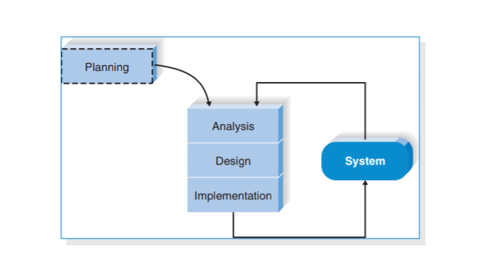

*Figure 1 Methodology Model*

### **3.2.1 Significance of Agile Methodology**

The preference for such a choice for a methodology is that it accommodates changing requirements throughout the development process, collaboration between the stakeholders and developers throughout the project thus maintains simplicity and ensures early and frequent delivery of working software hence customer satisfaction.

Hence suitable to my project as it allows continuous interaction with developers for requirements and review which can then be integrated to system iterations.

### **3.2.2 Stages of Agile Methodology**

The following tasks are going to be accomplished throughout SDLC of the project;

Agile Methods break the product into small incremental builds.

1. **Requirements** **Analysis**- we will gather requirements from experts and the stakeholders, thus coming up with the tasks to be performed.
2. **Design**- after clearly understanding the requirements we will plan how to build requirements into a product.
3. **Development**-here we will be able to develop testable functional software.
4. **Testing**-the software developed will be tested (code quality, unit testing, integration testing, performance testing and security testing)
5. **Deployment**-after it has passed the testing phase it would be ready for deployment.ie being released for production.
6. **Review**- after deployment, the system will be reviewed for more functionality and updates(management).

## **3.3 Data collection**

Data collection is the process of gathering and measuring information on variables of interest, in an established systematic fashion that enables one to answer stated research questions, test hypotheses, and evaluate outcomes.

There are a number of ways in which data can be collected, an example would be through questionnaires, surveys, observations and interviews. These methods can be used accordingly depending on the type of project you have and the types of data you want to retrieve.

This project will use unstructured interviews and observation as data collection. An unstructured interview or non-directive interview in which questions are not prearranged. Observation methods involve the process of observing and describing the behavior of the subject.

This method we are going to use in the farming area and the place where they conduct agricultural markets. Also, on some organization which involves the agricultural market in Tanzania.

# 

# CHAPTER FOUR

# SYSTEM ANALYSIS AND DESIGN

## **4.1 Introduction**

This chapter analyses the requirements collected and from them the modeling of the system and the design of various parts can be addressed and developed to meet the requirements specified. This provides a complete description of all the functions and specifications of the agricultural products marketing and shipping logistics system.

## **4.2 Requirement Analysis**

Through the data resulted from data collection methods used including unstructured interviews and observation, the following core system functional requirements were captured for the development of Agricultural products marketing and shipping logistics system;

### **4.2.1 Functional Requirements**

Functional requirement is a specification of behavior between outputs and inputs of a system or its components. Functional requirements indicate what a software must do and how it must function. The following are the core functional requirements :

1. Management of Users
2. Management of Order
3. Management of Products
4. Management of cart
5. Management of transaction

**Activities for Each Core Function**

Activity of each functional requirement is described in the table below:

|  |  |  |  |  |  |  |
| --- | --- | --- | --- | --- | --- | --- |
| **Ref. No.** | | | **FUNCTION DESCRIPTION** | | **CATEGORY** | |
| **F1** | **Management of users** | | | | |
|  | F1.1 | System should allow the registration of users in a system  (except for administrator) | | Evident | |
| F1.2 | System should assign users role and permissions in the system | | Hidden | |
| F1.3 | System should allow user to log in the system using their credentials | | Evident | |
| F1.4 | System should allow users to update their password when they forget it. | | Evident | |
| F1.5 | System should allow users to update and view their profile details. | | Evident | |
| F1.6 | System should allow admin to delete seller | | Evident | |
|  | F1.7 | The system should allow seller to logout. | | Evident | |
| **F2** | **Product management.** | | | | |
|  | F2.1 | System should allow farmer to insert new product | | Evident | |
| F2.2 | System should be able to display all products added | | Hidden | |
|  | F2.3 | System should be able to allow farmer to edit products details | | Evident | |

*Table 1 Core Functions*

|  |  |  |  |
| --- | --- | --- | --- |
|  | F2.4 | The system should allow buyer to see all products available. | Evident |
| F2.5 | System should be able to allow administrator to view products | Evident |
| **F3** | **Cart management** | | |
|  | F3.1 | The system should allow buyer to search for crops they need. | Evident |
| F3.2 | The system should allow buyer to add product to cart. | Hidden |
| F3.3 | The system should be able to display all product added to the cart | Evident |
|  | F3.4 | The system should allow buyer to delete or empty the cart list | Evident |
| F3.5 | The system should display minimum quantity order increments. | Evident |
| **F4** | **Order management** | | |
|  | F4.1 | The system should be able to calculate cost of the total products in the cart list | Hidden |
| F4.2 | The system should be able to display total price of the ordered products | Evident |
| F4.3 | The system should display the delivery option | Evident |
|  | F4.4 | The system should be able to display successful massage when order if completely made | Evident |
| **F6** |  | **Payment Management** |  |
|  | F5.1 | System should allow buyer to choose payment option | Evident |

*Table 2 Core functions*

### **4.2.2** **Non-Functional Requirements**

Non-functional requirements are the requirements that specify criteria that can be used to judge the operation of the system, rather than specific behaviors. These are the constraints by which the system is under, they are the quality or standards that the system should adhere to.

Agricultural products marketing and shipping logistics system non-functional requirements are summarized in the table below:

|  |  |
| --- | --- |
| **Attribute** | **Constrain** |
| Reliability | The proposed system which is agricultural products marketing and shipping logistics system, shall be reliable and efficiently interact with the user. Secure access of confidential data. |
| Usability | The interface should be user friendly and easily used and understood by the user. |
| Security | The system can guarantee maximum data that is stored due to authentication of every user that logs in. |
| Availability | 24/7 availability will be provided if there is an internet connection and server is available. System should be available in Kiswahili and English. |
| Operational | System should be able to support all commonly used browsers such as Chrome, Safari, Mozilla Firefox |

*Table 3 Non functional requirements*

## **4.3** **System analysis**

Analysis focuses on capturing the business requirements for the system. Analysis identifies the “what” of the system, and it leads directly into the design phase, during which the “how” of the system is determined.

### **4.3.1** **System Actors**

Actors of this system are;

* System administrator: are the ones who add or administer the list of the products, and administer the vendor(seller). Administrator can see the daily sell, also he can also see feedbacks given by the customer
* Customers: Are the end user of the system who will be viewing and buying the products and see the product prices and quantity available. Customer can also write feedbacks for the products and services
* Sellers: Are the ones who add their products to the database, which will be seen in the website by the customer who can buy the products by selecting the one they need. Sellers have special privileges than customers ,and the ability to manage the products added by them.

### **4.3.2 Identifications of use cases**

Use Cases is a list of actions or event steps that typically define the interactions between an actor and a system to achieve a goal. The following shows the list of system actors with their respective descriptions and use cases;

|  |  |  |
| --- | --- | --- |
| Actor | Description | Use Case |
| Administrator | Main personnel that supervise, maintain and manage the whole system. | 1. Login 2. Manage user(s) 3. Logout |
| Customer | An individual or business that purchases and sells products. | 1. Registration 2. Login 3. Search product 4. Add To Cart 5. Select payment 6. Confirm order 7. Place order 8. Logout |
| Seller | This is an individual or other entity that offers a product in return of payment. | 1. Registration 2. Login 3. Add product 4. Prepare purchase order 5. Confirm purchase order 6. Ship product 7. Logout |

*Table 4 use cases*

### **4.3.3 Use Case Diagrams**

The use case diagram illustrated by figures below models the functionality of the proposed system using actors and use cases. It illustrates how the users of the proposed system can interact with the system through the system’s user interface after the data is sent to the database.

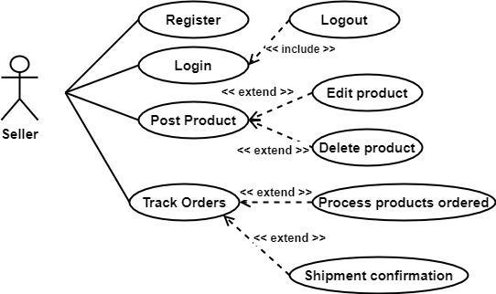

*Figure 2 Seller use case diagram*

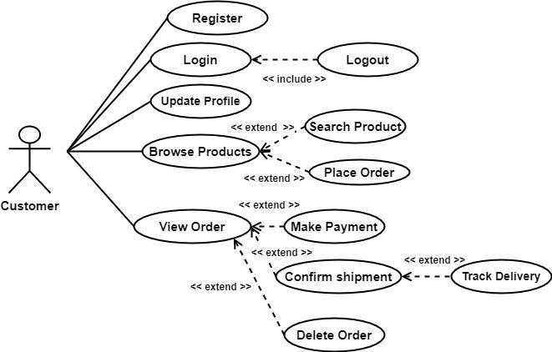

*Figure 3 Customer use case diagram*

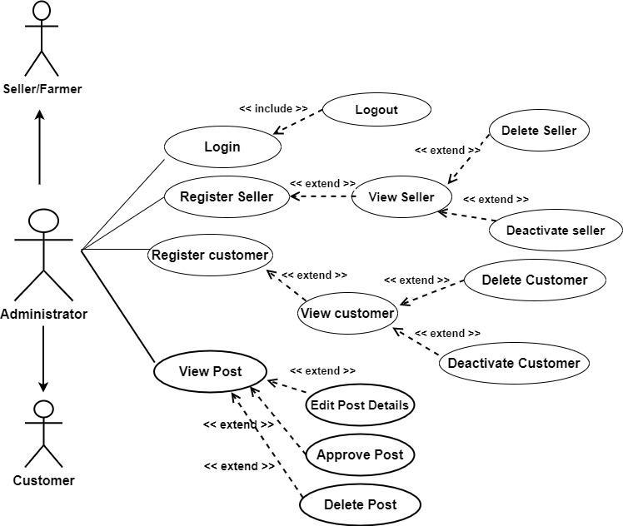

*Figure 4 Administrator use case diagram*

Figure below illustrates how the users of the proposed system can interact with the system through the system’s user interface after the data is sent to the database, it’s a summary for use case diagrams shown above

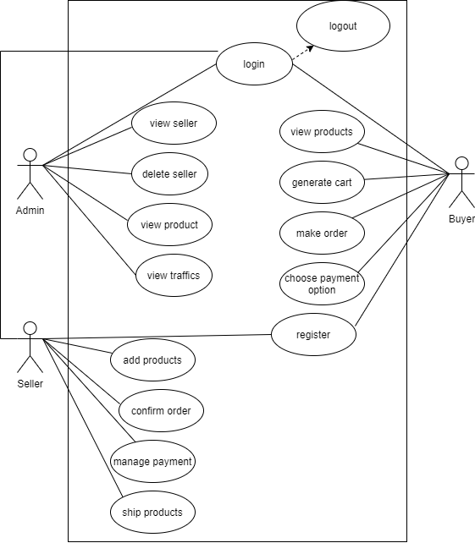

### **4.3.4 Use Case Descriptions**

Use case description describes the process in use case between the actor and the system and the use case goals. Below are the use case descriptions.

**Table 4. 4 Register Use Case Description**

|  |  |
| --- | --- |
| **Field** | **Description** |
| Use case: | Registration |
| Actors: | Administrator, Customer and seller |
| Short description: | Administrator, Customer and seller can register into the system through the registration form. |
| Pre-condition: | The user must not already exist in the system |
| Post-condition: | The user needs to verify email |
| Main flow: | 1. The developer connects to system domain link for registration 2. User fills the registration form and submits 3. User will be sent an email on regarding to verification process 4. After verification is success the use given access to the system and directed to home page |
| Exception flow: | If there is an empty required field left the system won’t allow submission |

*Table 5 Register use case description*

**Table 4. 5 Login Use Case Description**

|  |  |  |
| --- | --- | --- |
| **Field** | **Description** |  |
| Use case: | Login |  |
| Actors: | Administrator, Customer , Seller |  |
| Short description: | The administrator/customer/seller uses valid registered credentials to access the system. |  |
| Pre-condition: | The user must have already registered in the system |  |
| Post-condition: | The user can access the system |  |
| Main flow: | 1. The system displays the login page 2. User enters login credentials 3. The system validates login credentials 4. The system redirects the user to system dashboard |  |
| Exception flow: | If the user enters incorrect login credentials the system will deny | |
|  | access and prompt user to repeat login | |

**Table 4. 6 Logout Use Case Description**

|  |  |
| --- | --- |
| **Field** | **Description** |
| Use case: | Logout |
| Actors: | Administrator, Customer , Seller |
| Short description: | The administrator/customer/seller can logout the system. |
| Pre-condition: | The user must have already login in the system |
| Post-condition: | The user session gets destroyed and the system displays the welcome page |
| Main flow: | 1. User clicks on the logout button 2. User gets signed out to the system 3. The system returns to the welcome page |

*Table 7 Logout of use case description*

**Table 4. 6 Place order Use Case Description**

|  |  |
| --- | --- |
| **Field** | **Description** |
| Use case: | Place order |
| Actors: | Customer |
| Short description: | The customer can make order in the system. |
| Pre-condition: | The must have navigate to the list of product |
| Post-condition: | The product ordered by customer must be in the list |
| Main flow: | 1. Customer clicks menu button 2. Customer choose product 3. Customer make order |

*Table 8*

**Table 4. 6 add product Use Case Description**

*Table 9*

|  |  |
| --- | --- |
| **Field** | **Description** |
| Use case: | Add product |
| Actors: | Seller |
| Short description: | The seller adds products to the system. |
| Pre-condition: | The products added to the system must be of food crops category only |
| Post-condition: | The product get added to the specific list in the system |
| Main flow: | 1. The system display the add list button 2. The seller click the button to add product 3. System update the list |

### **4.3.5 Data Flow Diagram (Context Diagram)**

A context diagram is a level 0 data flow diagram that defines the boundaries of the system and the flow of information between the system and external entities. Context diagram for the agricultural products marketing and shipping logistics system is;

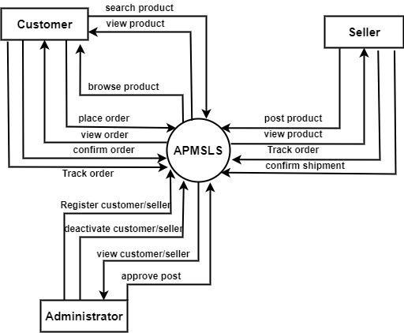

*Figure 5 Context Diagram*

#### 

### **4.3.6 User Management Flow Chart**

User Management flow chart, shows how the system admin interact with system components to manage system user, the flowchart is shown by figure below:

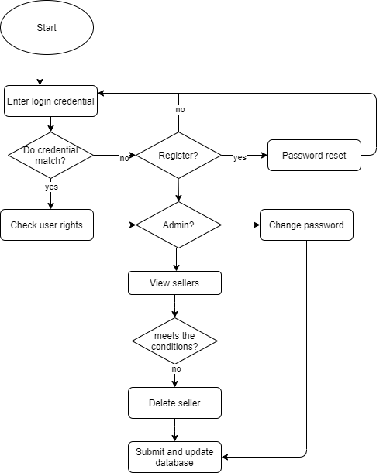

*Figure 6 User Flow Chart*

### **4.3.7 System Sequence Diagrams**

Sequence diagram describes the interaction among events over time in an exchange way. The sequence diagram assists in predicting how the system will behave, respond and obtain a clear view of the process. Below are the sequence diagrams for Agricultural products marketing and shipping logistics system

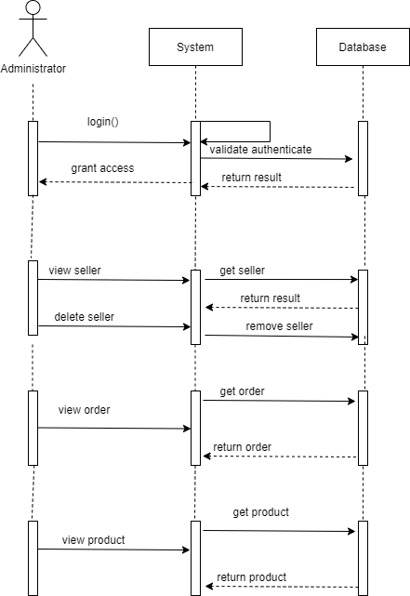

*Figure 7 Administrator Sequence Diagram*

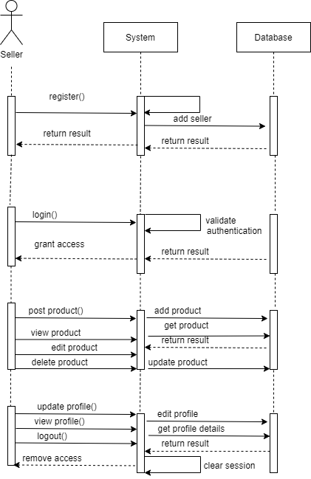

*Figure 8 Seller Sequence Diagram*

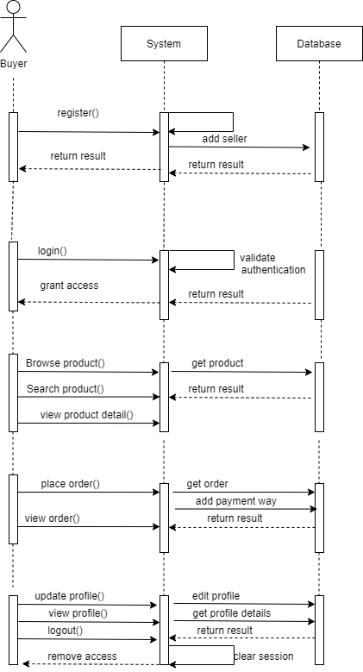

*Figure 9 Customer Sequence Diagram*

## 

## 

## 

## **4.4 System Design**

### **4.4.1 Architecture Design**

The proposed system is Client/Server, Web-based and mobile-based application. Architectural design of a system describes the components of the system such as the software, hardware, the relationship between the functional components in the system and their behaviors. Architectural design of the proposed system is as shown in figure below.

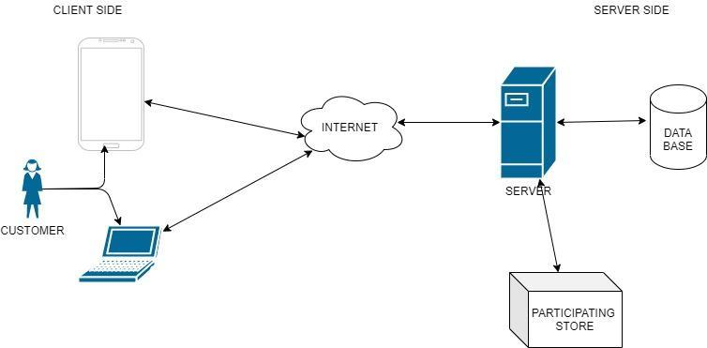

*Figure 10 Architecture design*

According to architectural design above, the system has two main subsystem operations:

* The database system responsible for structured way of data storage and retrieval.
* The Server System responsible for handling HTTP requests.

### **4.4.2 Database** **Design**

An Entity Relationship Diagram (ERD) is a diagrammatic presentation of entity sets of the system and how they associate with one another. The ERD helps to explain the logical structure of databases. Below Figure is the ERD for agricultural products marketing and shipping logistics system.

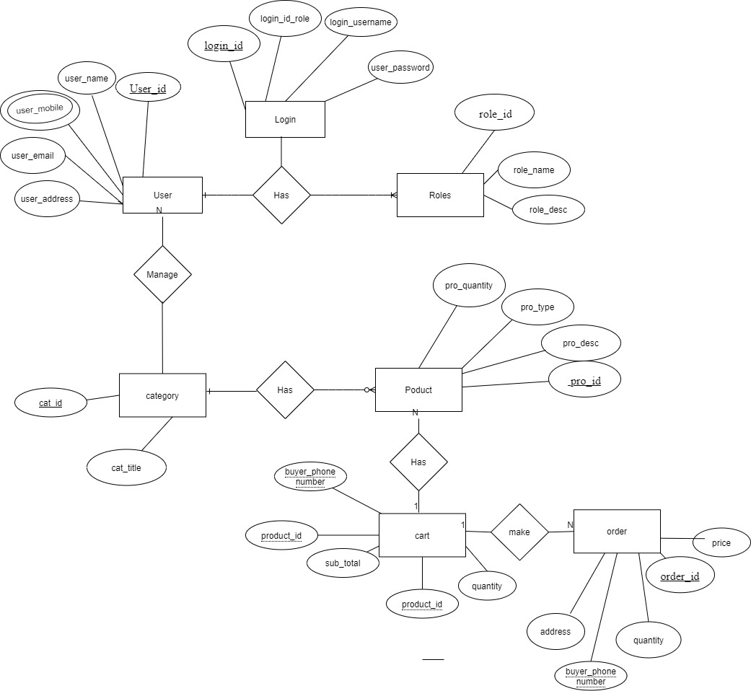

*Figure 11 Entity Relationship Diagram*

# CHAPTER FIVE

# IMPLEMENTATION AND TESTING

### **5.1 Introduction**

This chapter shows the implementation of the project taking into account the objectives and functional and non-functional requirements as explained in chapter 1.3 and 4.2 as well as the system design, in order to reach the main objective and accomplish the project work.

### **5.2 Database Implementation**

### The database of the system was implemented using MongoDB through NodeJS and express framework, for creating and storing the system models as designed in chapter 4.4.2.

Figure 12 shows database and tables

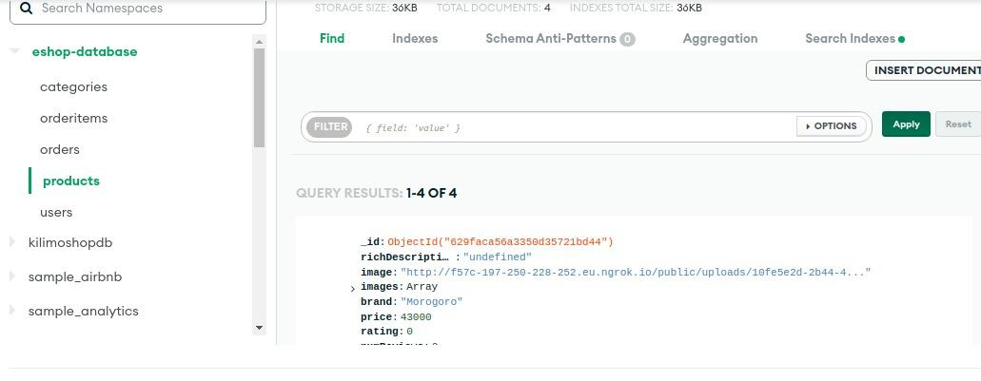

*Figure 12 Database Tables*

### **5.3 Back-End Implementation**

The system Back-End logic was implemented by creating an application programming interface using NodeJS runtime environment and express.js framework by creating Models and Routes, so as to provide interaction between the user interface of the mobile application and the system database and make HTTP requests. This back-end logic system handles the GET, POST, PUT and DELETE requests as well as all data validations and manipulations. Figure13 and 14 below shows the models and routes of the system

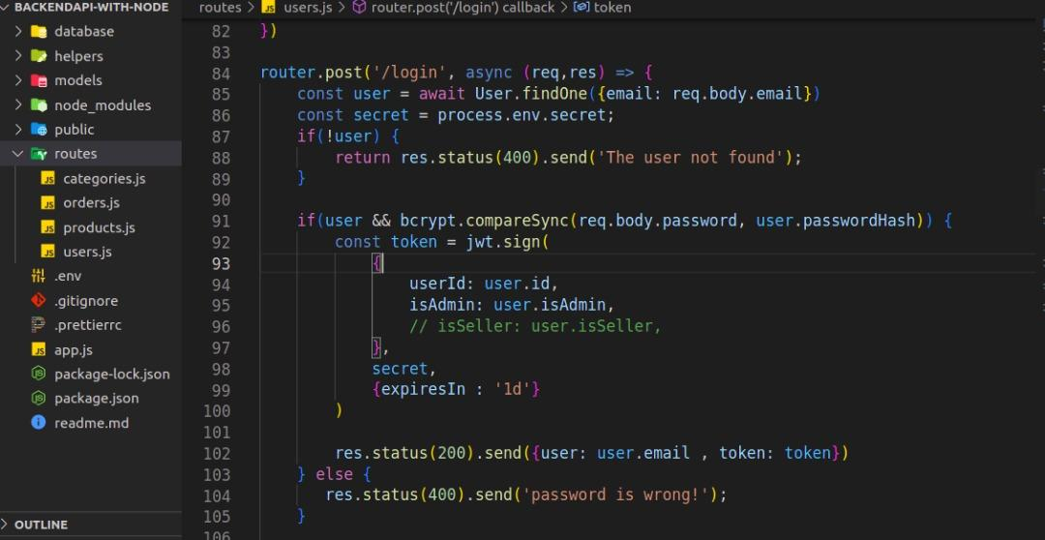

*Figure 13 API routes*

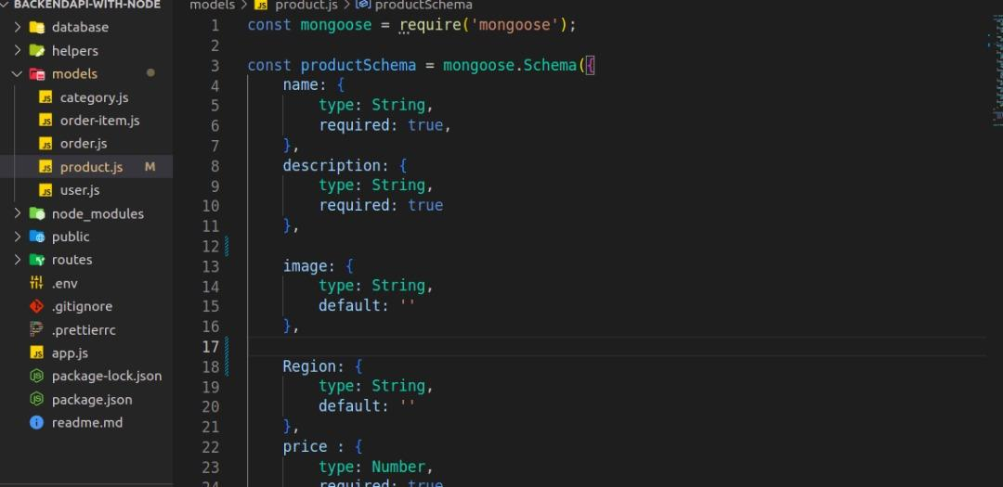

*Figure 14 Models*

### **5.4 Front-End Implementation**

The mobile application user interfaces were implemented using React Native framework and Redux library, for the mobile application user interactions and experience.

#### **5.4.1 Authentication**

Figure 15 and 16 represents Register and Login Views for authentication respectively as shown below:

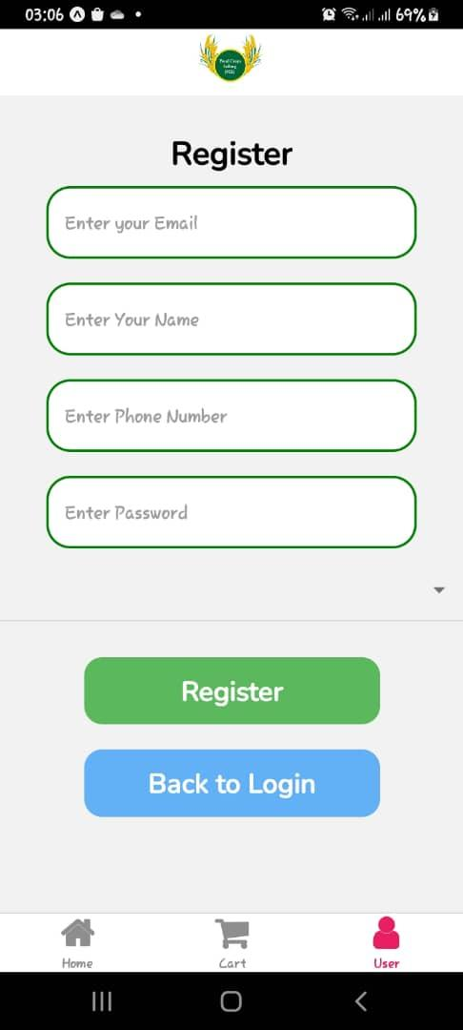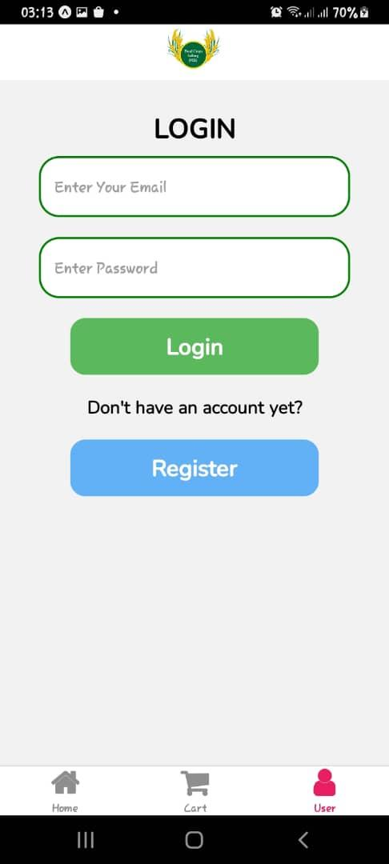

*Figure 15 Register View Figure 16 Login View*

#### **5.4.2 Customer Interfaces**

Figure 17 and 18 represents products listing view and Search view respectively:

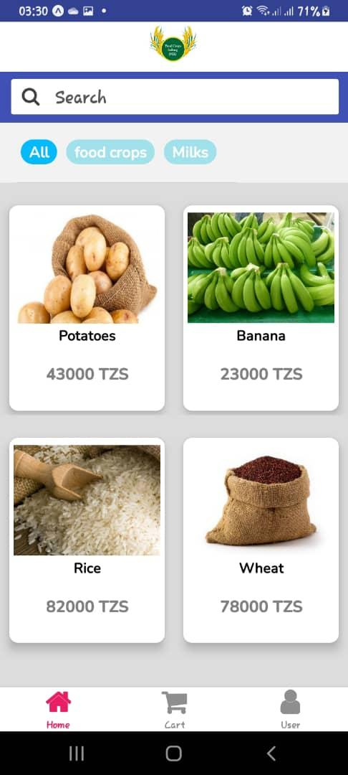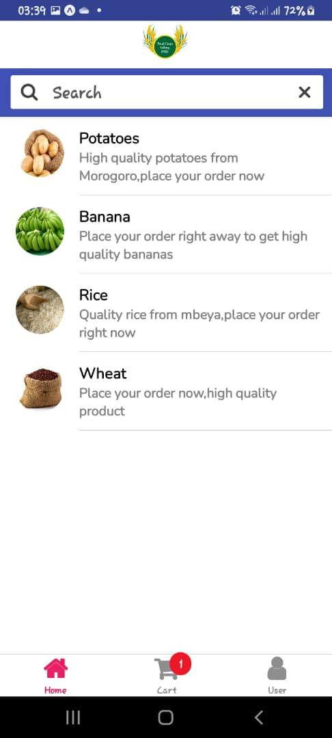

*Figure 17 Product List View* *Figure 18 Search View*

Figure 19 and 20 represents single product view and cart view respectively:

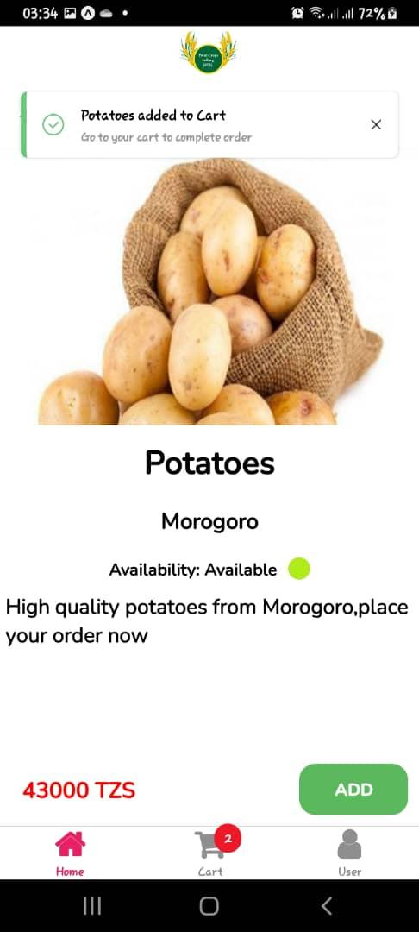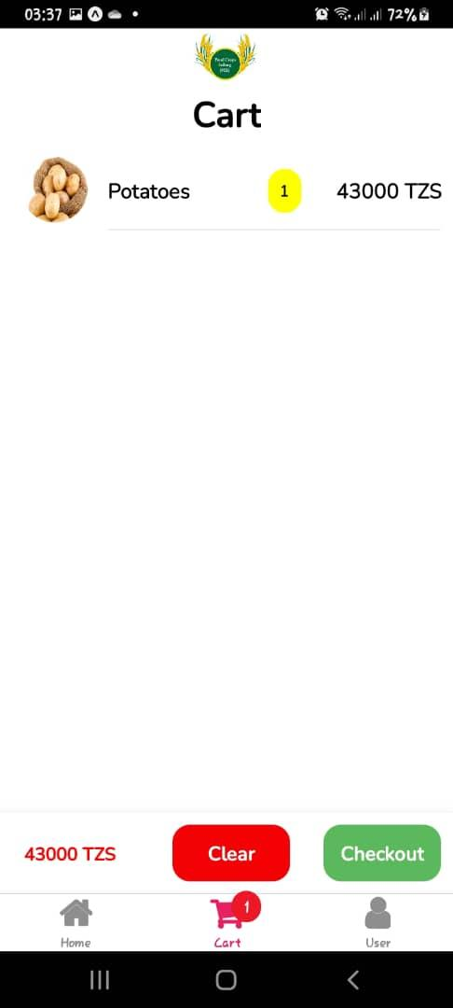

*Figure 19 Single Product View Figure 20 Cart View*

Figure 21 shows a screen for adding shipping addresses where products can be delivered and

Checkout screens for shipping details, payment and order confirmation are shown below

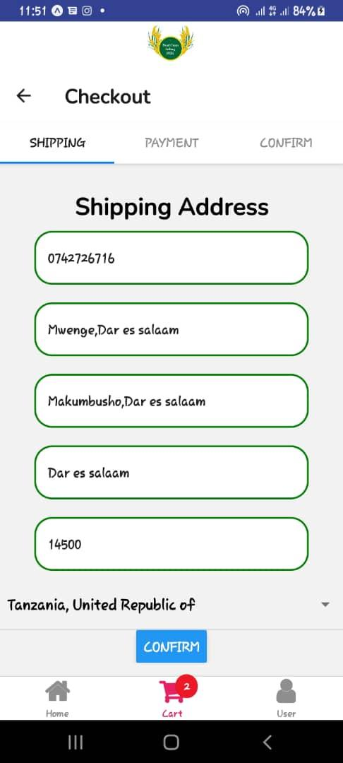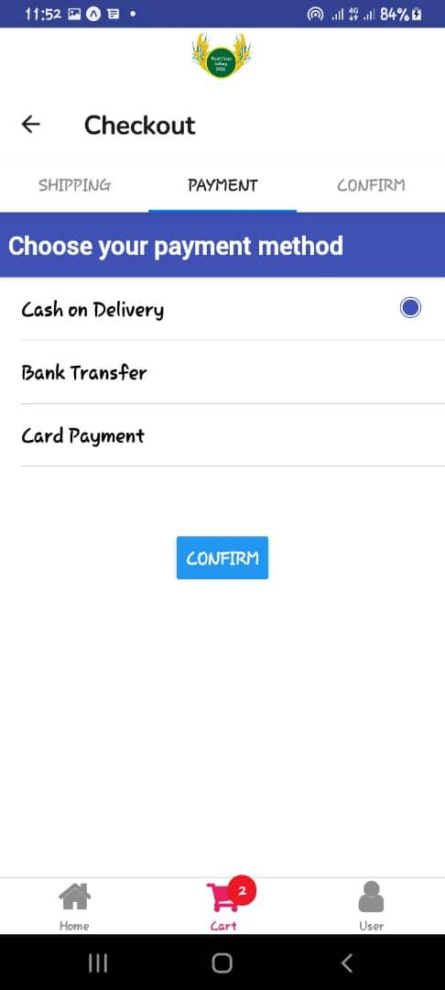

*Figure 21 Checkout View(Shipping) Figure 22 Payment View*

Figure 23 shows the confirmation page after adding shipping addresses and payment details from Figure 21 and Figure 22 respectively.

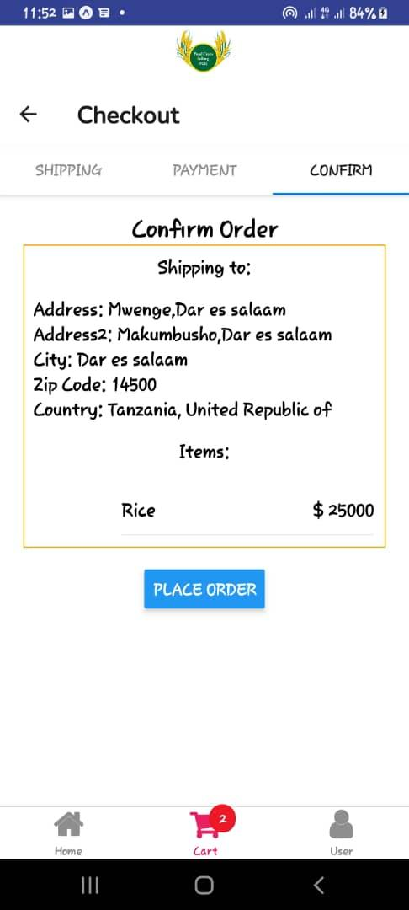

*Figure 23 Confirm View*

#### **5.4.3 Seller Interfaces**

Figure 24 shows that sellers(farmers) can view products they added, search for products they added and view orders placed by customers and Figure 25 shows that sellers(farmers) can add new product after clicking a button from Figure 24 as shown below:

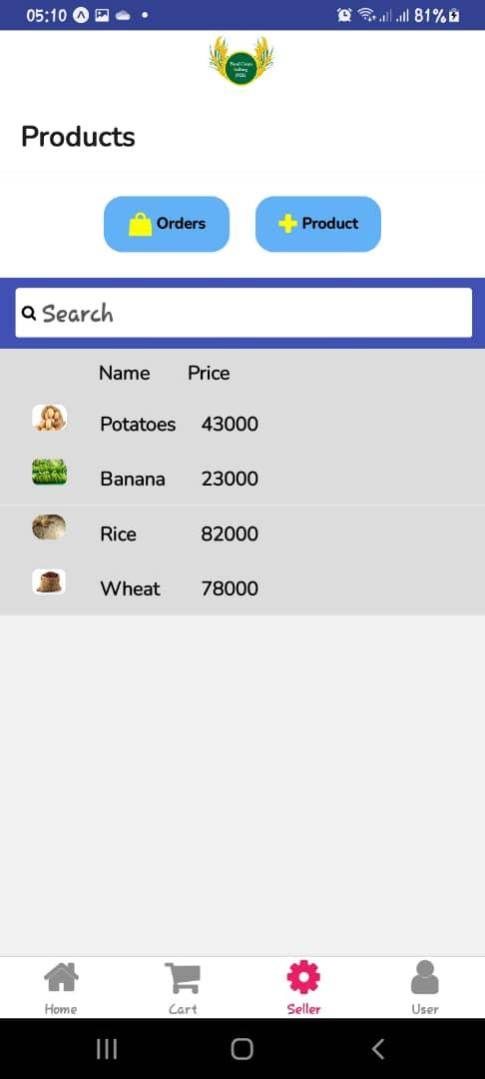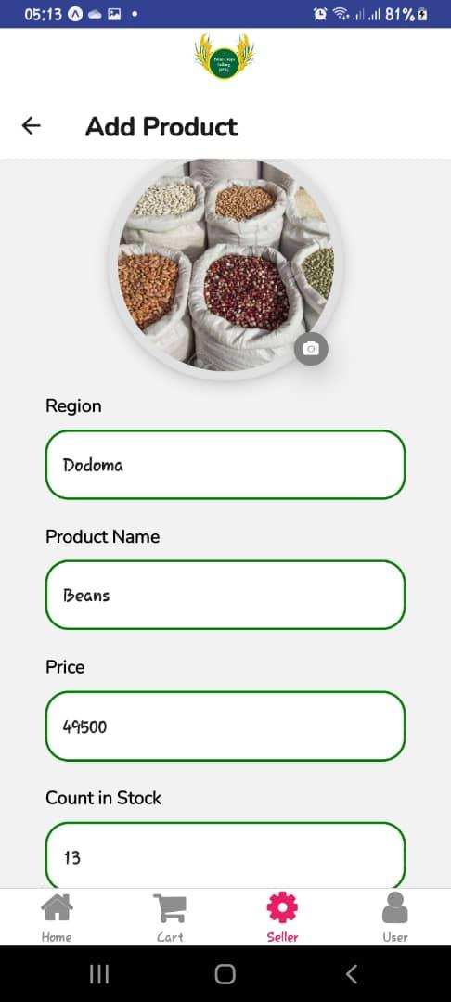

*Figure 24 Product List View Figure 25 Add Product View*

Figure 26 shows that sellers(farmers) can edit and delete products they added and Figure 27 shows an Edit Screen as shown below:

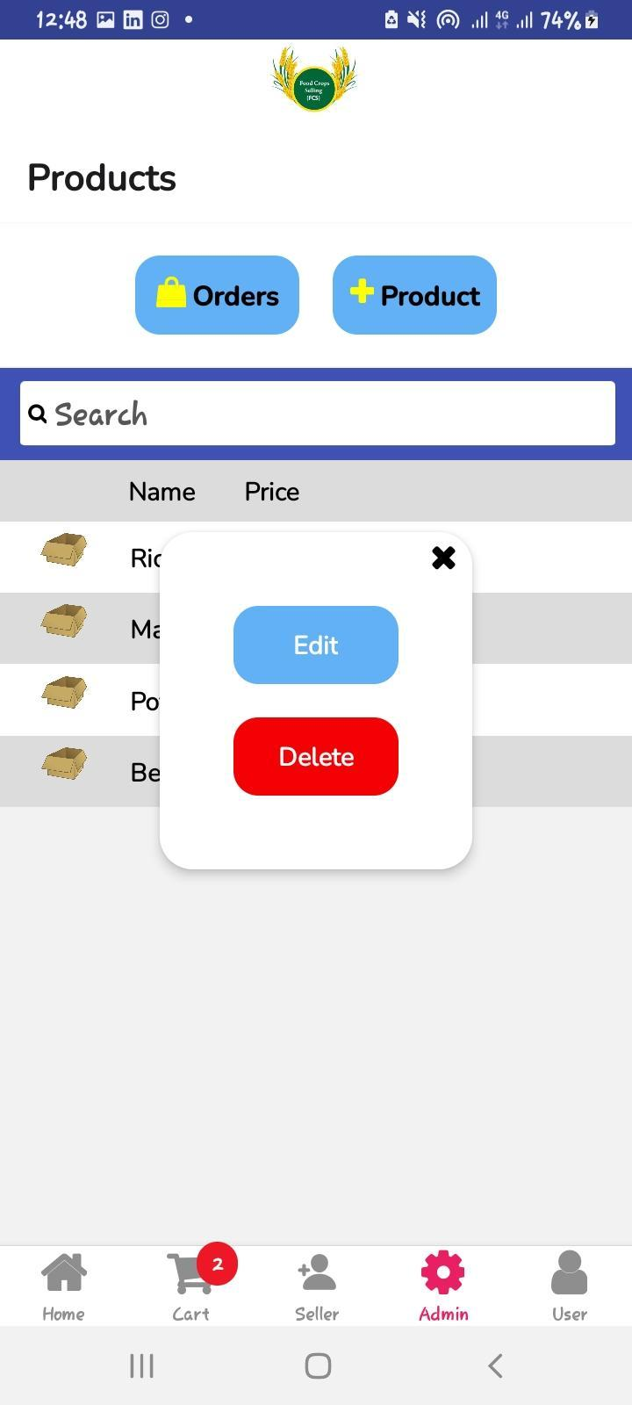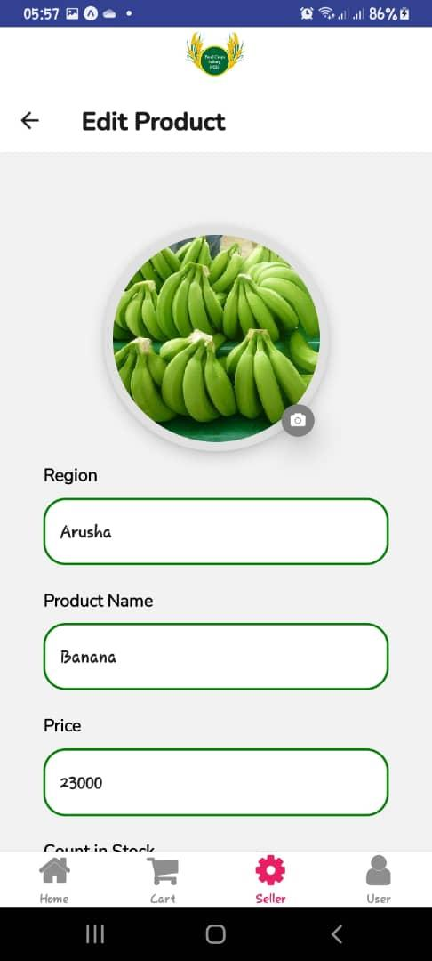

*Figure 26 Modal View Figure 27 Edit Product View*

### **5.6 System security implementation**

HS256 algorithm used to sign in users for security purposes as When JSON Web Tokens are created, they are typically signed by its issuer. This allows the recipient of the token to validate that the token received contains all of the information encoded by the issuer unmodified and as intended.

HS256 is a symmetric algorithm that shares one secret key between the identity provider and your application. The same key is used to sign a JWT and allow verification of that signature. Figure below shows how the algorithm works to sign in users.

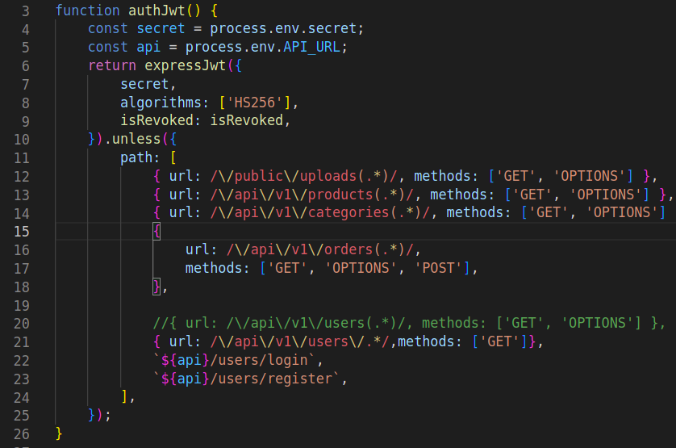

*Figure 28 Security(bcrypt)*

Also a library called bcrypt for password hashing in order to send encrypted password to the database. Consider the figure below showing how it was used:

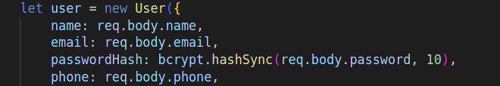

### **5.7 System testing and validation**

System testing involves checking how the system behaves in various scenarios to ensure data integrity and system reliability. In this project, systems have been tested under unit testing and overall system testing after system implementation so as to check if it meets the specific objectives and requirements as defined earlier. Modules that have been tested are as follows:

#### **5.7.1 Login Testing**

The application performs user authentication, and the user is allowed to login if already registered to the system otherwise an error message will be displayed notifying the user that no such account was found. Also registered users must enter the correct email and password for access to be granted otherwise the system will display an error message of incorrect user login inputs. This can be illustrated on the Figure 29 and 30 below:

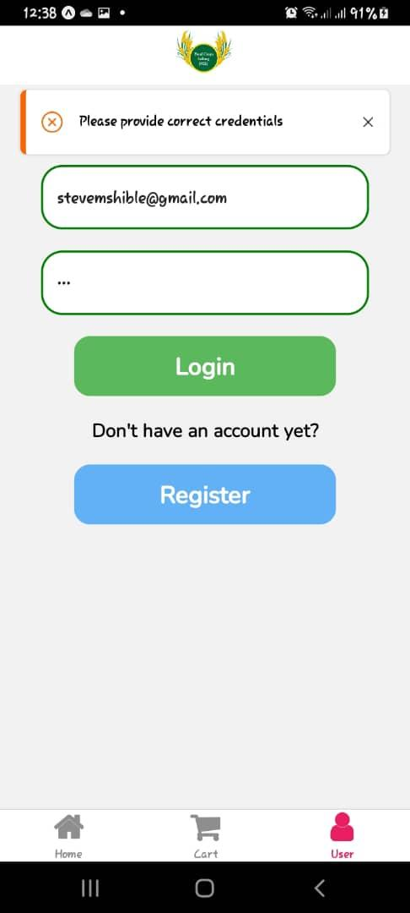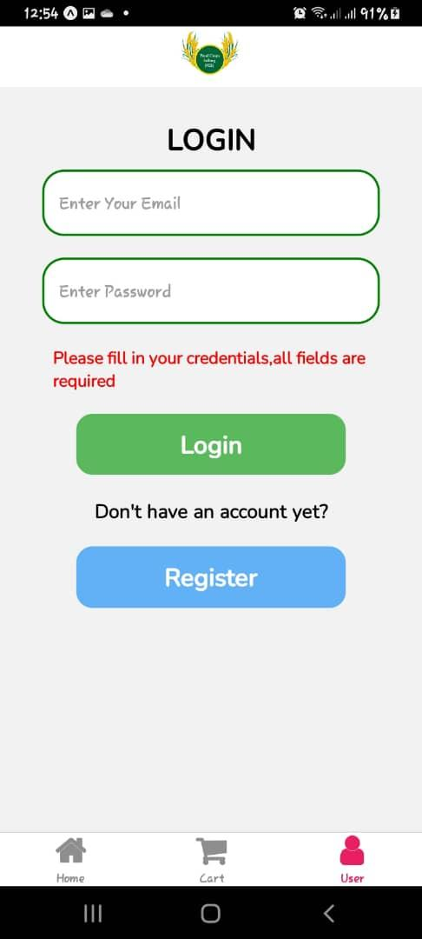

*Figure 29 Login validation View Figure 30 Login validate*

#### **5.7.2 Registration Testing**

Both farmers and customers can register through registration. All fields in the form are being validated both on client and server side, they are required and of specified type so if otherwise specified error message will pop up. Some fields such as email and mobile number are unique hence if an error message is already displayed the password must also match the confirm password. Figure 31 below illustrates:

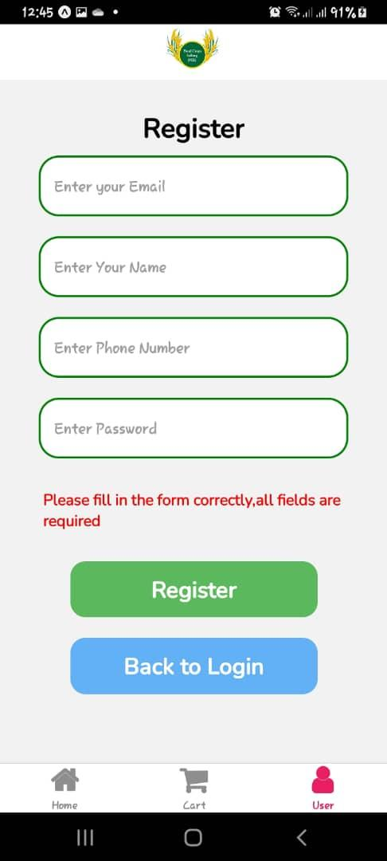

*Figure 31 Register validation*

# 

# 

# CHAPTER SIX

# CONCLUSION AND RECOMMENDATION

### **6.1 Conclusion**

This project followed almost all procedures for carrying out software development, taking into account agile methodology used to carry out the project towards accomplishment of the main objective to develop agricultural products marketing and shipping logistics system mobile application.

The project is complete based on the scope but it is easily scalable to additional functionalities to make it more usefully and better, these features may include a machine learning system for recommending popular and most sold products and direct messaging between sellers(farmers) and customers.

**6.1.1 Mapping on How Implementation Satisfies Project Specific Objectives**

Table 6. 1: Implementation Satisfies Project Table

|  |  |  |
| --- | --- | --- |
| S/N | Specific Objective | Implementation |
| 1 | To gather requirements of the system by using the requirement gathering methods such as an unstructured interview to obtain both functional and non-functional requirements of the system. | Complete |
| 2 | To design the system based on realized requirements (functional and non-functional requirements) | Complete |
| 3 | To develop a web based and mobile system that will be used for marketing agricultural products. | Complete |
| 4 | To test the app with the users and gathered feedback | Complete |
| 5 | To design a database system that will store the logs of the captured data | Complete |

*Table 10 implementation satsification*

### **6.**2 **Recommendation**

The core subject such as software development should also be in practical’s that aid the student in implementation of different projects, in all levels of undergraduate studies.

The Ministry of Agriculture should look for a way to support this project as it will help farmers to connect with the customers within and outside the country, hence improves farmer’s life as well as increase country’s income through taxes.

# REFERENCES

1.System Analysis and Design 5TH Edition. By Allan Dennis

2.Object oriented Analysis and Design. By Dr Ellen Ambakisye Kalinga

3. SOFTWARE ENGINEERING 9th Edition. By Ian Somervillee

4 "What to Know about Shipping Food Across Borders | The UPS Store Canada" <https://www.theupsstore.ca/what-to-know-about-shipping-food-across-borders/>

5. "Agrimp" <https://agrimp.com>

6. <https://www.sourcetrace.com/blog/transport-agriculture-marketing/>

7. <http://jnkvv.org/PDF/10042020083748concept%20of%20ag%20markeing_EgEcon530.pdf>

8. <https://reactnative.dev/>

9. Stack Overflow, <https://stackoverflow.com/>

10. GitHub, <https://github.com/>

# APPENDICES

**Appendix A**: Project schedule

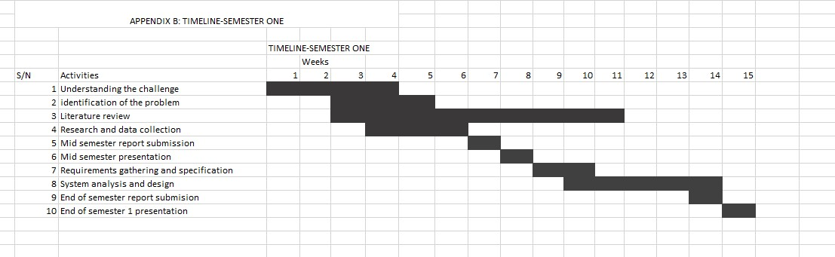

*Figure 32 Project Schedule*

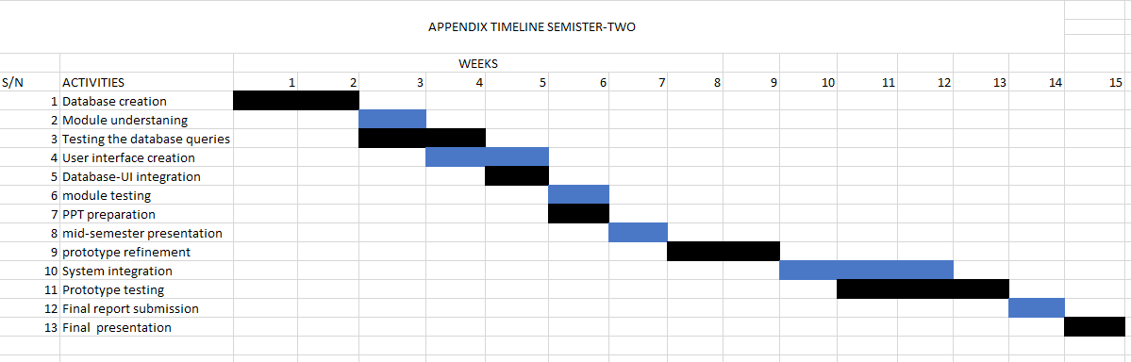

**Appendix B**: Project budget

|  |  |
| --- | --- |
| **Expense** | **Cost (Tsh)** |
| Transport | 87,500 |
| Stationary | 20,000 |
| Internet | 125,000 |
| **Total** | **255,000** |

*Table 11*

*Table A. 1 Project Budget*